# SPRINT 3: Classification of Arrhythmia by Using Deep Learning With2-D ECG Spectral Image Representation

# Description of USN and Screenshots:

**USN-5:**

As a user, I can enter the webpage and view the homepage about the information about Electrocardiography (ECG) giving a clear perspective of the signals. I must also be able to comprehend all medical jargon related to Arrhythmia such as ECG, Coronary Heart Disease, Cardiomyopathy and its types.

# Screenshot:

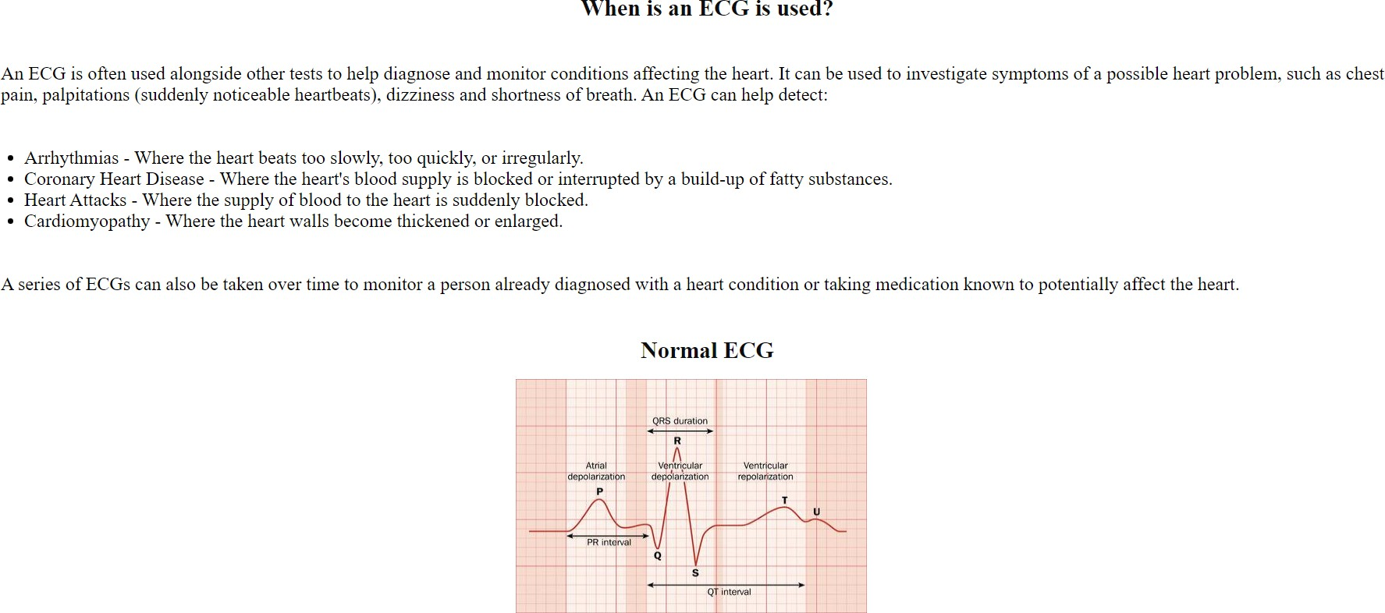

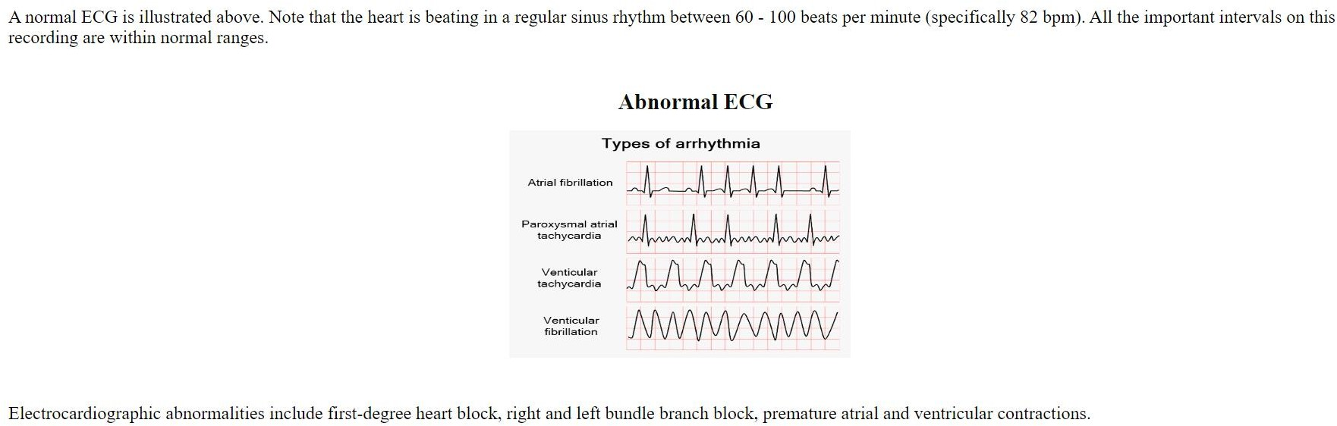

The HTML file used to build the app_flask.py page includes:

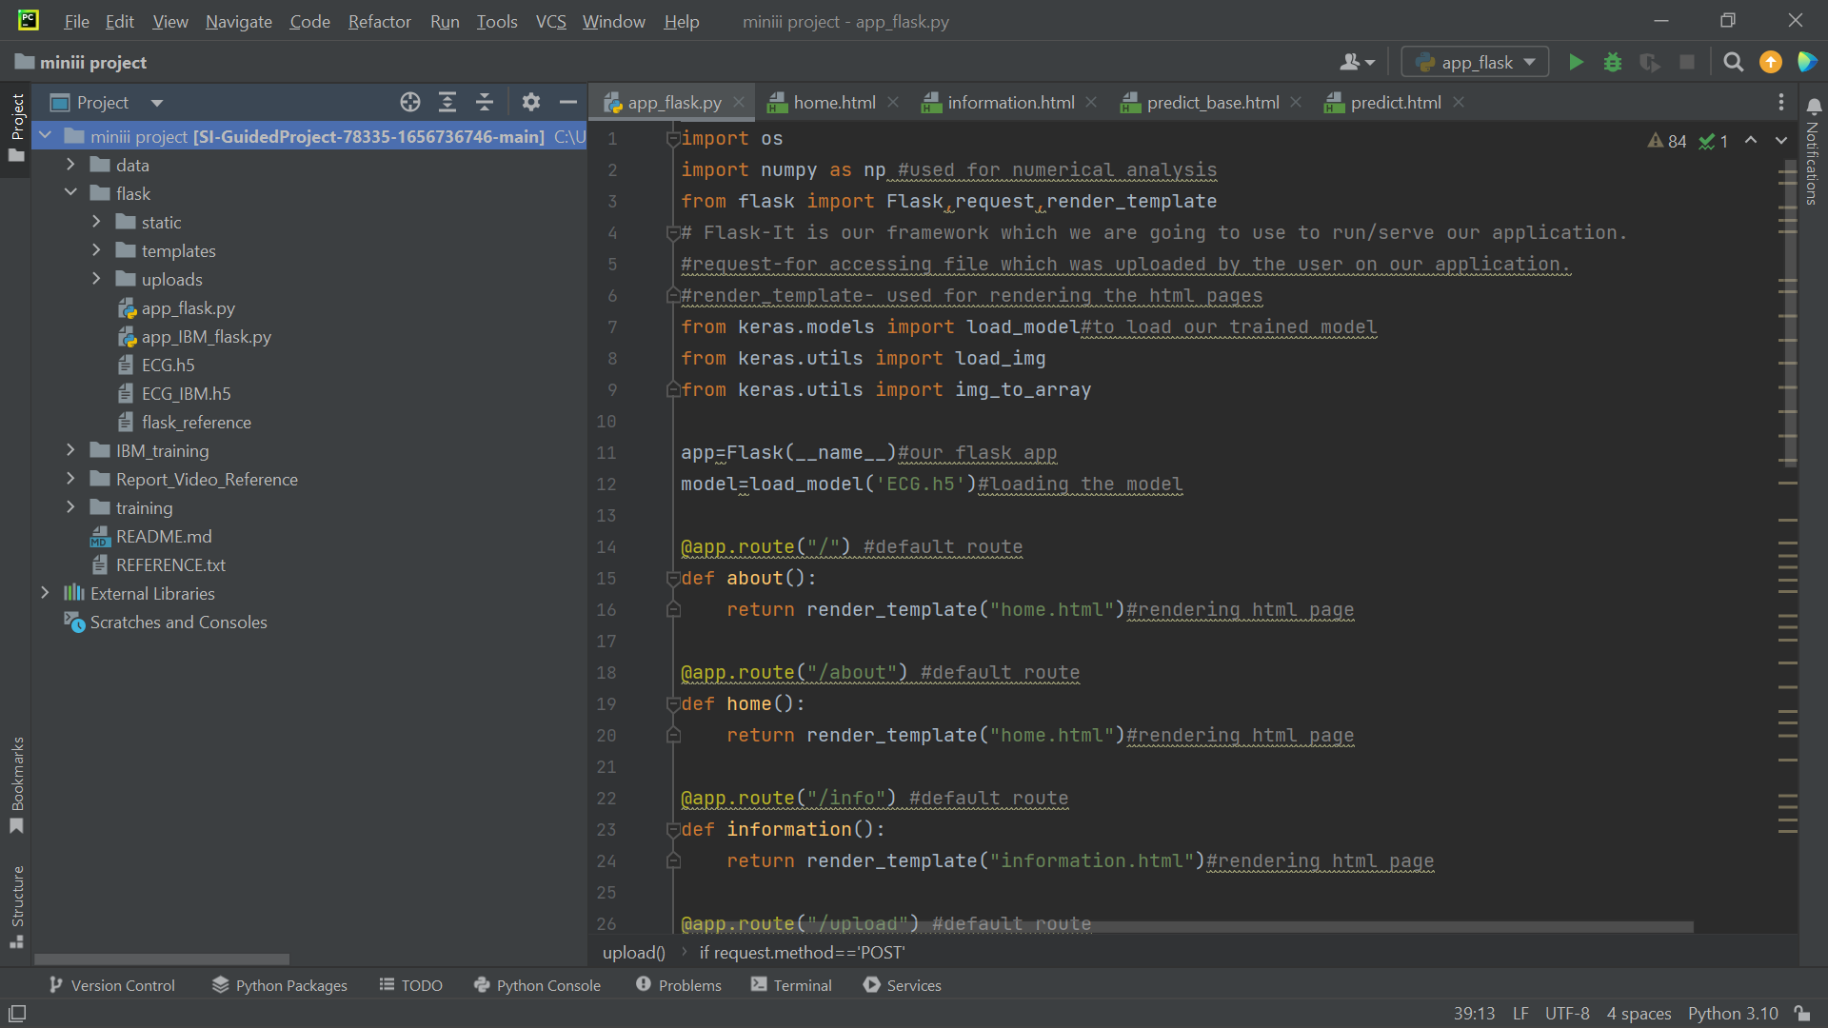

The HTML file used to build the Home.html

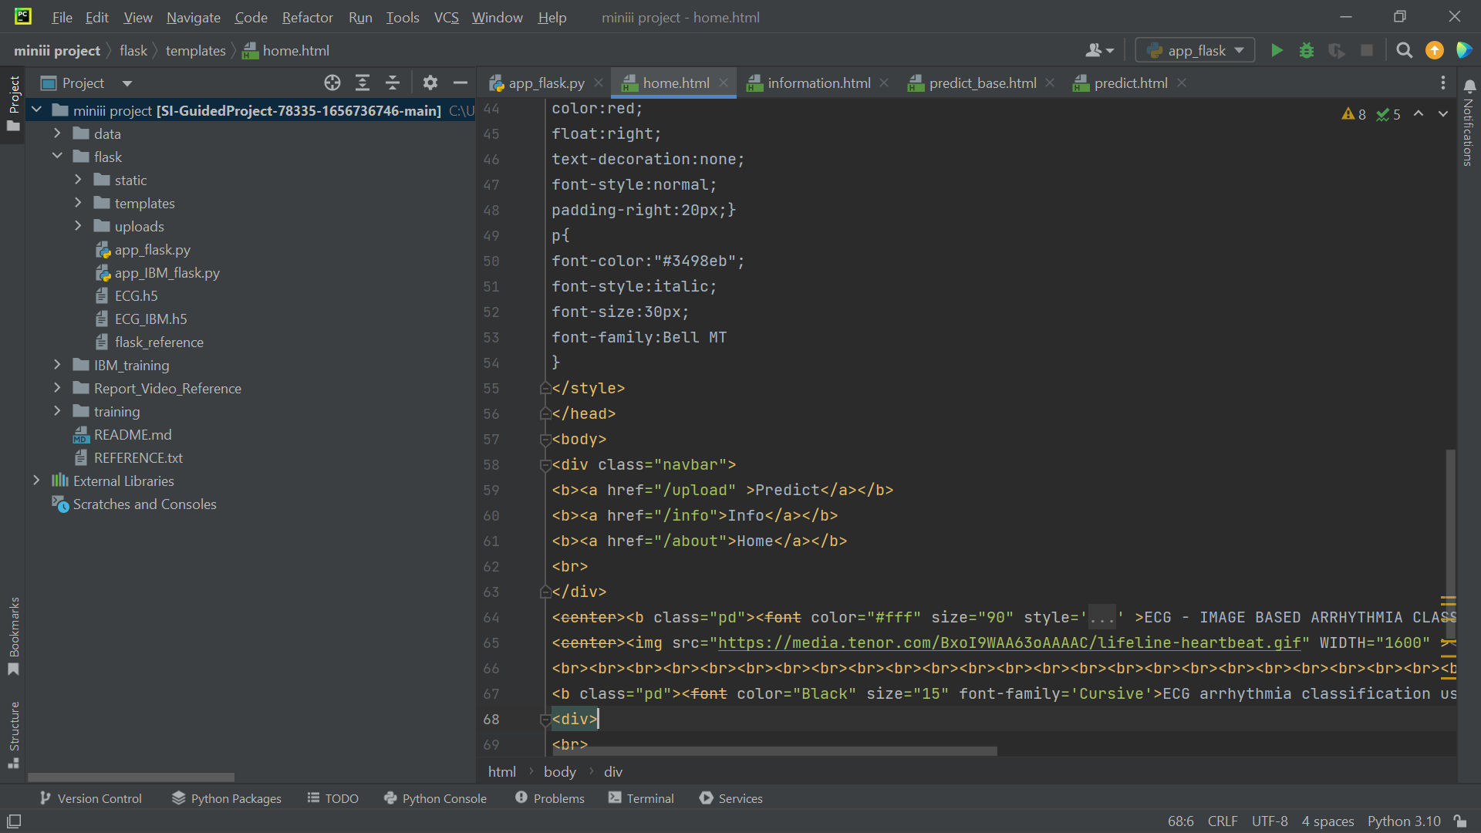

The HTML file used to build the information.hmtl

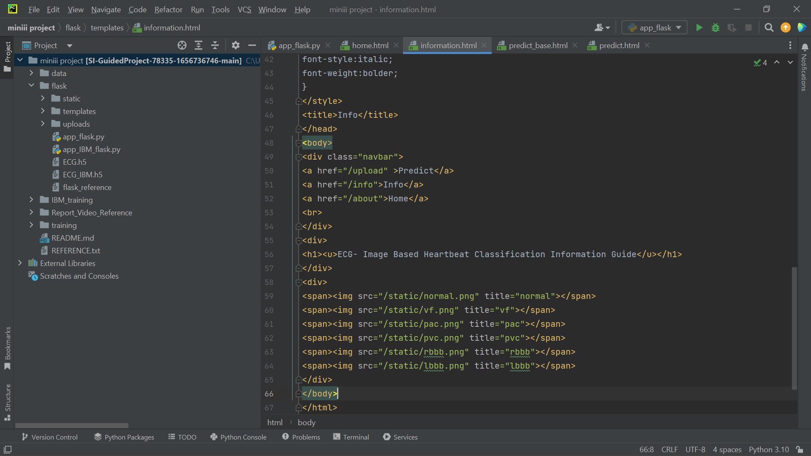

The HTML file used to build the predict_base.html

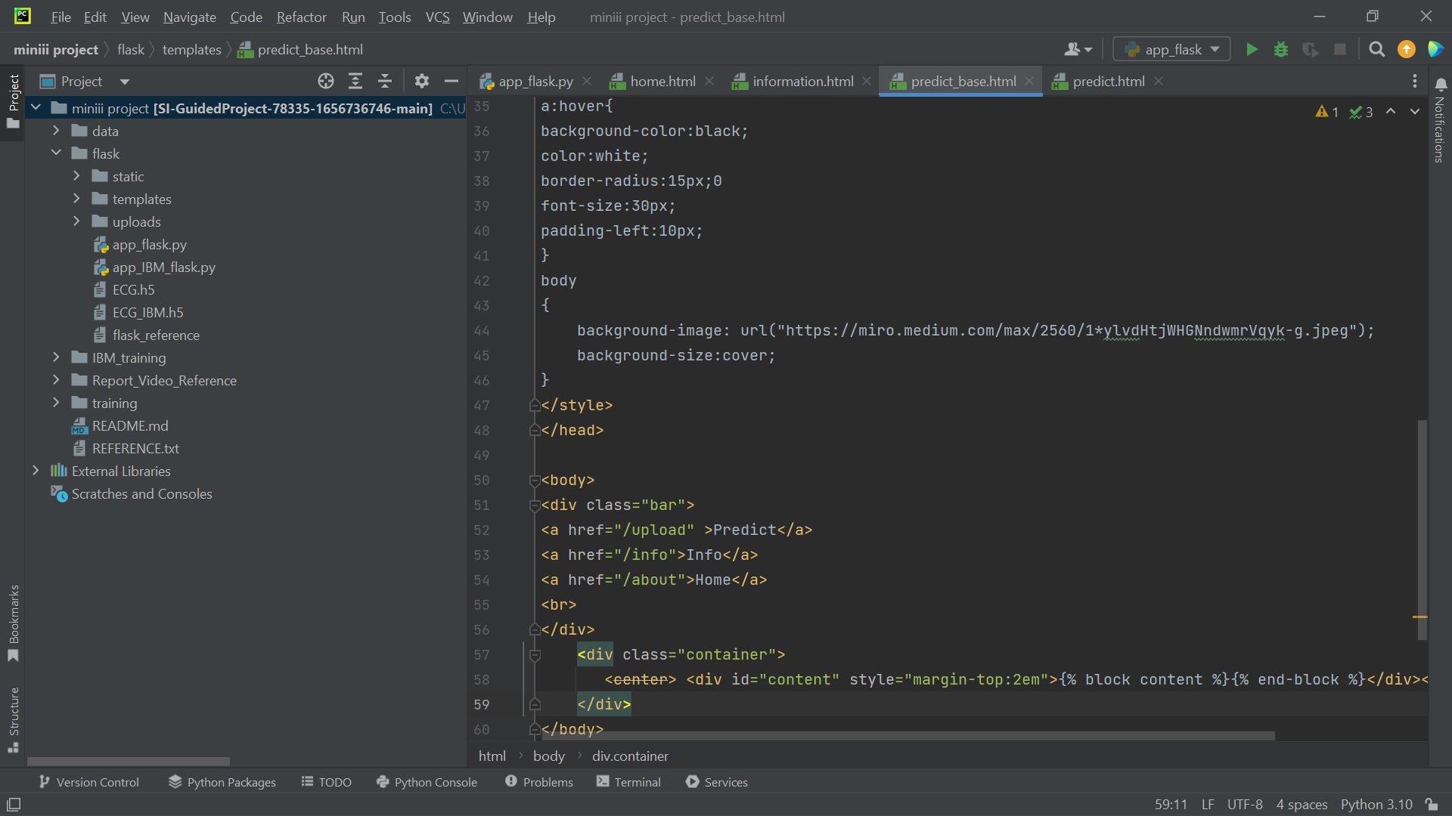

The HTML file used to build the predicate.html

